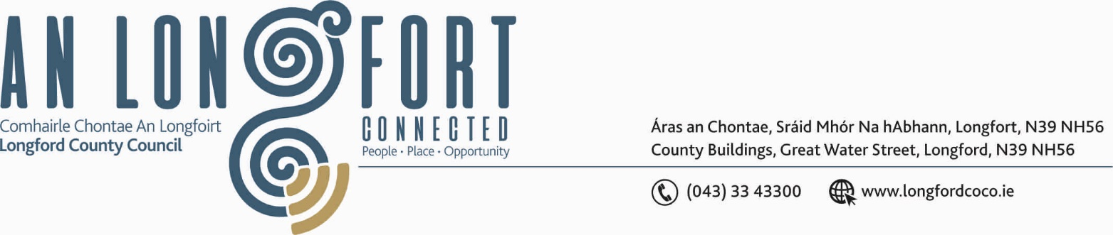

BALLYMAHON MUNICIPAL DISTRICT

11th February 2019.

To: Each Member of Ballymahon Municipal District.

Dear Member,

You are requested to attend Meeting of Ballymahon Municipal District to be held in the Council Chamber, Aras on Chontae, on Friday, 15th February 2019 at
11.00 a.m. to transact business, as set out on the Agenda hereunder.

Yours sincerely,
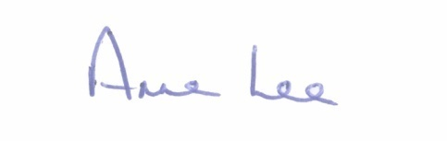

_______________
Anne Lee,
Meetings Administrator.

AGENDA

1. Consideration of Adoption of Part 8 Report (Planning and Development Act 2000 (as amended) and Planning and Development Regulations 2001) (as amended) in respect of upgrading and alteration of the existing public realm, to include footpaths, tree planting, street furniture and lighting, undergrounding of public wires, tabletop pedestrian crossing, revisions and alterations to car parking, signage and all associated site works.
The proposed development forms an integral part of a wider regeneration plan to provide a focal point within the town centre, improving pedestrian accessibility, connectivity and amenity within Edgeworthstown overall - report to follow.

